**System Design Tiny Url:**  
 **Functional Requirements:**

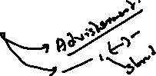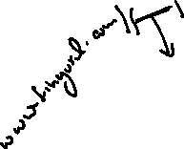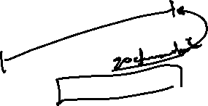

Given a URL, our service should generate a shorter and unique alias of it. This is called a short link. This link should be short enough to be easily copied and pasted into applications.



When users access a short link, our service should redirect them to the original link.

Links will expire after a standard default timespan. Users should be able to specify the expiration time.

**Non-Functional Requirements:**

The system should be highly available. This is required because, if our service is down, all the URL redirections will start failing.

URL redirection should happen in real-time with minimal latency.

Shortened links should not be guessable (not predictable).